Tab 1
By Dallas Plowden

Takes place around 1865 to 1895

Chapter 1: Windreach

Chapter 2: The Lost Trail

Chapter 3: The Badlands

Chapter 4: The Dust Plains

Tab 2
By Dallas Plowden

Main Protagonist: Elias Granger
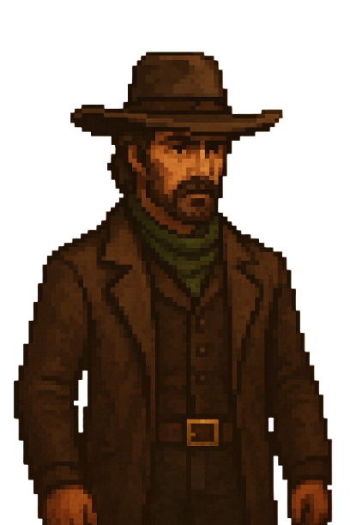

This is the main character of the story who before the events of the story he was under the teachings of Rowan Creed (Will be written down later within this document)they had a falling out which led to his whole town being massacred by Rowan and he was left for dead. The events of this left him with nothing but his guilt for not protecting his town, So he believes Rowan must face justice for the countless he has slaughtered and lives he’s ruined past and current.

Main Antagonist: Rowan Creed

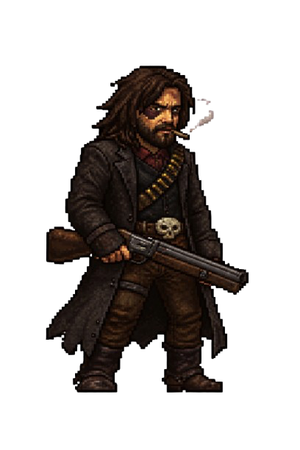
The Villain of the story who taught most of the things that Elias knows, He found potential within Elias and taught him for many years until he showed him his true colors by showing Elias exactly what he was training him for. The massacre of Windreach, Elias’ home town. He left him for dead and abandoned the remains with his crew.


Antagonist (Boss 1): “Ironfang Isaiah” Crowder

One of the members of Rowan’s crew

